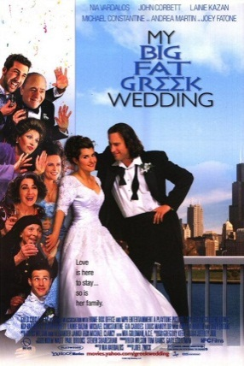
FILM QUESTIONS:

Instructions: In the spaces provided, answer the following questions after watching the movie. Be sure to use specific examples from the movie to support your answer. Your final answers must be typed or neatly printed on a separate sheet of paper!

1. | At the beginning of the movie, Toula says “there are three things Greek girls must do.” What are these three (3) things? How do these expectations affect Toula’s life?
________________________________________________________________________
________________________________________________________________________
________________________________________________________________________
________________________________________________________________________
2. | How are Toula and Ian similar? How are they different? Fill in the chart below to answer these questions:
 | Similar | Different
Family

Traditions / Customs

Rituals / Routines

Beliefs

Values

3. | Describe at least three (3) obstacles that Toula had to face as she tries to bring Ian into her family. Why do you think that it is so difficult for families to accept people from other cultures?  ________________________________________________________________________  ________________________________________________________________________  ________________________________________________________________________  ________________________________________________________________________
4. | For each of the following quotes from the movie, explain the context (who said it, when it was said) and the meaning or significance of the quote.
 | (a) | “Don’t let your past dictate who you are, but let it be a part of who you become.”  ____________________________________________________________________  ____________________________________________________________________  ____________________________________________________________________
 | (b) | “We’re all different, but in the end, we’re all fruit.”  ____________________________________________________________________  ____________________________________________________________________  ____________________________________________________________________
5. | How can we continue to practice our cultural traditions while incorporating traditions of modern North American society?  ________________________________________________________________________  ________________________________________________________________________  ________________________________________________________________________  ________________________________________________________________________

