CGG30
Cruise Ships

- <http://www.cruiselinejob.com/cruiselines.htm>
  - Select a cruise line from this list. Describe the details for one ship.
- Google Norwegian Cruise Lines, Norwegian Jewel.
  - Visit the deck plans page for cruise ship owned by Norwegian Cruise Lines called
the Norwegian Jewel
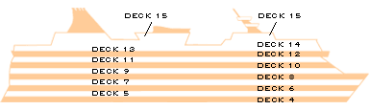
At the top of the page, click on the ship deck and list the features/activities for the following decks:
a) Deck 13
b) Deck 12

- a) What form of media is published at www.porthole.com ?  b) Who would benefit from using it? Explain. | 