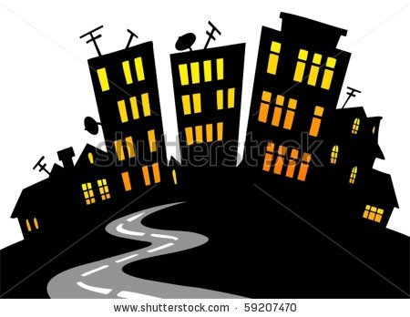
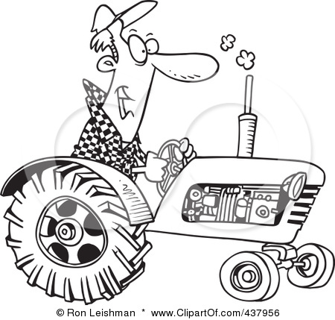
Canada’s Urban-Rural Divide
Cartoon Analysis – Class Discussion
Check out the cartoon on page 131 of Experience Canada.
1) What is the point of this cartoon?
2) Why do people live in cities despite these problems?

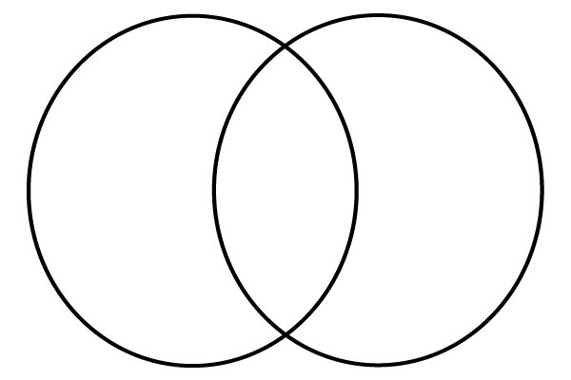

Transportation
Housing
Infrastructure
Recreational Activities
Services
Overall environment

Other

Our Urban-Rural Division
- Look at the graph on the board. What do you notice? When does this shift take place?

- What might explain this pattern?

- What percentage of Canada’s population live in urban areas today?

Notes: Fill-in-the-blanks
- Today, more than _______ of Canada’s population lives in ________ areas. When a rural area slowly turns into an urban area because of an increase in population, it is called __________________.
- This shift is caused by ____________________; when people move from rural areas to urban areas.
- People move to urban areas to find _____________, access services and to access better _____________________.
- A lot of rural-urban migration can lead to _________________; when a city spreads out into _______________.

The Urban Hierarchy: What makes a city a city or a town a town?
Place it!
Draw a line to show where we would find these services.

1. Apple Store
2. Doctor’s office
3. Several hospitals and cancer treatment centre
4. McDonald’s
5. No health care services
6. Walmart

Every major city in Canada went through the urban hierarchy, or ranking, as it developed:

Impacts of Urban Sprawl
Make a flow chart to illustrate some of the possible consequences of urban sprawl.

Urban Sprawl

For people
For the environment

